**LAB MANUAL**

**Home Task # 4**

**ME-15: Computer Systems And Programming**



# Submitted by:

# Hamza Saif (481070)

**DEPARTMENT OF MECHANICAL ENGINEERING**

**NATIONAL UNIVERSITY OF SCIENCES AND TECHNOLOGY,H12**

**TASK#1**

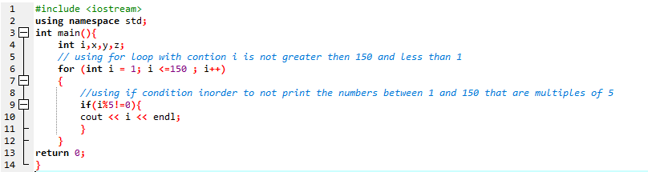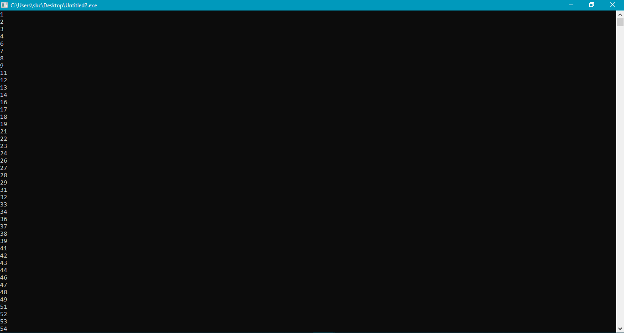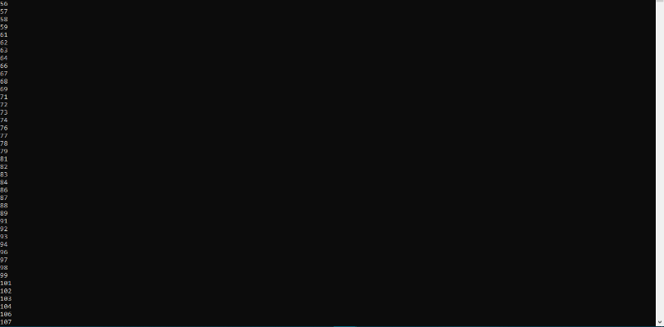

**TASK#2**

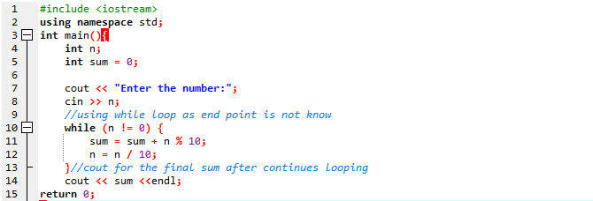

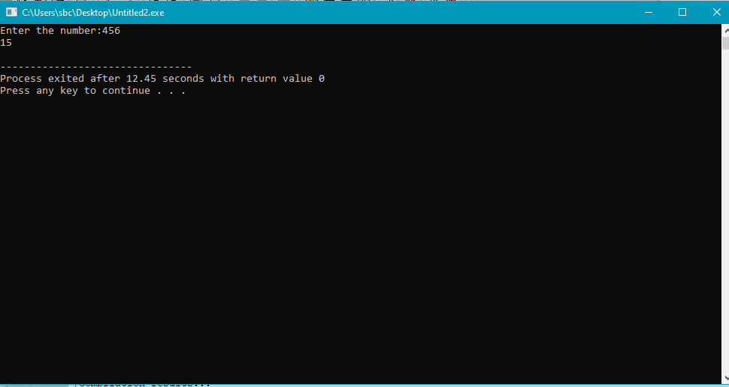

**TASK#3**

